Social Implications: The digital divide
si_digital_divide.html — Social Implications

The Digital Divide

The 'Haves' vs The 'Have Nots'…
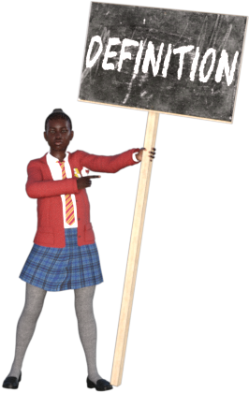
The Digital Divide is the separation between those people who have access to computers and the internet vs those people who do not have this access.
The Digital Divide is a human tragedy on a very large scale.
Just because you are taking this course you are putting yourself on the right side of an invisible line that can be as difficult to cross as the Grand Canyon.
Learning about (and understanding) the Digital Dvide is all about numbers and statistics. You can only measure the effect of the digital divide by compaing the income of people with access to ICT & the internet with those that don't have this access. You also compare types of job, lifestyle, education, etc. After doing a lot of research, analysis, statistics and comparison you arrive at proof of something we all sort of know instinctually:
People on the "Have" side of the Digital Divide tend to live longer, healthier, more fulfilled lives with greater incomes.
Try to imagine doing research without a computer. Or looking for a job without access to a computer. Or trying to set up a business…. Almost anything that we do - for work or in our personal lives - can be made easier by having access to technology and by knowing how to use that technology effectively.

Solutions to the Digital Divide
On the broader, macro scale the Government holds most of the responsibility for bridging the Digital Divide. Government policy, spending and decision making has a huge effect on just how wide the Digital Dvide is in a country. Here are just 3 examples of the impact that Government can have.
The Government controls the tax and duties on importing computing devices (most are not made here). It can also make these devices available in schools and libraries.
The Government sets education policy and so controls just how much emphasis is placed on teaching the effective use of ICT to the new generation of citizens.
The Government controls licensing and use of communications technology in the country. In South Africa mobile (cellular) communications companies have been waiting a long time to get access to the extra radio spectrum that they need to increase the speed and performance (and hopefully reduce the cost) of cellular data. That radio spectrum will only become available when the government switches TV over to digital broadcasting (instead of analogue broadcasting). This has not yet happened and is many years behind schedule.
On a personal level, people who know about ICT can help others to learn to use it more effectively. People lucky enough to have computing devices can allow others to access / use them - and when they upgrade they can give their old devices to people who need them rather than selling them / dumping them in the trash / leaving them in a drawer or storeroom somewhere.

Solutions to the Digital Divide
Find out more...


Who tends to be on the wrong side of the Digital Divide?
Click the icon in the top right corner of this block to find out the answer.
Older People (especially over 65)
People in low income households
People living in Rural areas
People with no / low education
People with long term illnesses or disabilities
People in

Does the Digital Divide only apply to 'Third World' / Developing Countries?
Click the icon in the top right corner of this block to find out the answer.

No.
The Digital Divide is something that takes place on a Global scale - and also seprataes the population in all countries.
This means that America has a Digital Divide problem, so does the UK.
BUT: the scale of the problem in developed countries is less than the scale of the problem in Developing / 'Third World' countries.
The graphics below may help to give you more insight into the problem…
Internet Penetration by Country

Global Map of Internet Penetration by country
This map does not represent the latest figures and statistics, but it does give you an idea of what percentage of the population of a country has access to the internet.
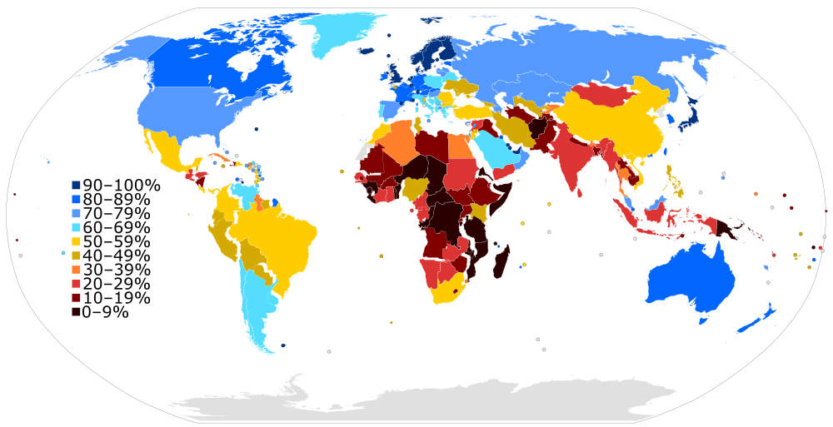
Image by By Jeff Ogden (W163) - Own work, based on figures from the Wikipedia:List of countries by number of Internet users article in the English Wikipedia, which is in turn based on figures from the International Telecommunications Union (ITU) for 2010 (updated to use figures for 2012 on 28 June 2013).The source code of this SVG is valid.This W3C-unspecified vector image was created with a text editor.This vector image includes elements that have been taken or adapted from this: BlankMap-World6.svg., CC BY-SA 3.0, Link
Return to the top of this panel
Digital Divide Infographic
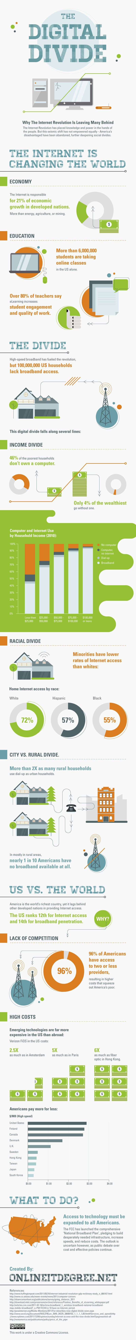

Video Links - The Digital Divide
We have selected and curated a set of videos on YouTube related to your course.
These videos are not created or owned by us.
They may display advertising and in some cases may contain limited amounts of swearing.

Notes for this Module
What to look out for and do in this module...
The FAQs are not questions that are likely to appear in exam papers - they are real questions that most people ask about the content.
Pay attention to the fact that this topic relies heavily on statistics. The only way to describe something like the Digital Divide is by measuring how many people do and do not have access to computers and the internet.
You then also measure those peoples standard of living, income, job type, etc.
In the end you see if a pattern emerges between the lifestyles / incomes, and the access to technology.

FAQs for this module
Questions on the Digital Divide - and their answers...

Network Types FAQ
View the questions or type in the term you are looking for below…
No results were found

Is the Digital Divide only a Third World Problem?
No. The problem may be greater overall in Third World / Developing countries, but all countries have a Digital Divide in their own population.

How can the Digital Divide be bridged?
By Government policy reducing the cost of access to technology (reduced taxes on devices, subsidised access to internet) AND focusing attention on education to ensure that people not only have access to the technology but know how to use it.
There is no fault originally, but as the gap widens and becomes more extreme fault must be laid at the feet of Government for either not recognising the problem or for not taking steps to rectify it.

Whose fault is the Digital Divide?
Return to the top of this Chapter

